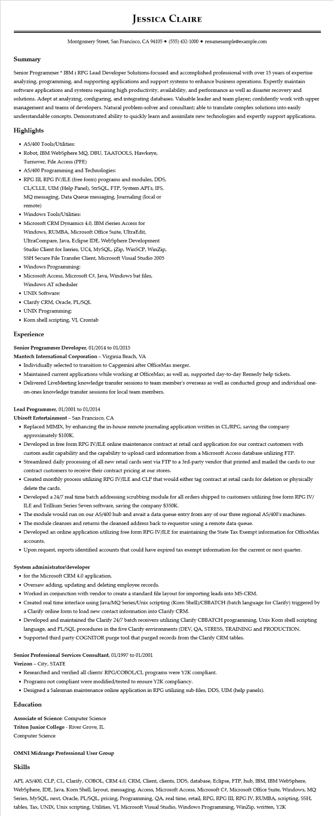
JESSICA CLAIRE
Montgomery Street, San Francisco, CA 94105 ⚫ (555) 432-1000⚫ resumesample@example.com
Summary
Senior Programmer * IBM i RPG Lead Developer Solutions-focused and accomplished professional with over 15 years of expertise analyzing, programming, and supporting applications and support systems to enhance business operations. Expertly maintain software applications and systems requiring high productivity, availability, and performance as well as disaster recovery and solutions. Adept at analyzing, configuring, and integrating databases. Valuable leader and team player; confidently work with upper management and teams of developers. Natural problem-solver and consultant; able to translate complex solutions into easily understandable concepts. Demonstrated ability to quickly learn and assimilate new technologies and expertly support applications. Highlights
• AS/400 Tools/Utilities:
• Robot, IBM WebSphere MQ, DBU, TAATOOLS, Hawkeye,
Turnover, File Access (PFE)
• AS/400 Programming and Technologies:
• RPG III, RPG IV/ILE (free form) programs and modules, DDS, CL/CLLE, UIM (Help Panel), StrSQL, FTP, System API's, IFS, MQ messaging, Data Queue messaging, Journaling (local or remote)
• Windows Tools/Utilities:
• Microsoft CRM Dynamics 4.0, IBM iSeries Access for Windows, RUMBA, Microsoft Office Suite, UltraEdit, UltraCompare, Java, Eclipse IDE, WebSphere Development Studio Client for Iseries, UC4, MySQL, jZip, WinSCP, WinZip, SSH Secure File Transfer Client, Microsoft Visual Studio 2005 • Windows Programming:
• Microsoft Access, Microsoft C#, Java, Windows bat files, Windows AT scheduler
• UNIX Software:
• Clarify CRM, Oracle, PL/SQL
• UNIX Programming:
• Korn shell scripting, VI, Crontab
Experience
Senior Programmer Developer, 01/2014 to 01/2015
Mantech International Corporation - Virginia Beach, VA
• Individually selected to transition to Capgemini after OfficeMax merger.
• Maintained current applications while working at OfficeMax; as well as, supported day-to-day Remedy help tickets.
• Delivered LiveMeeting knowledge transfer sessions to team member's overseas as well as conducted group and individual one- on-ones knowledge transfer sessions for local team members.
Lead Programmer, 01/2001 to 01/2014
Ubisoft Entertainment - San Francisco, CA
• Replaced MIMIX, by enhancing the in-house remote journaling application written in CL/RPG, saving the company approximately $100K.
• Developed in free form RPG IV/ILE online maintenance contract at retail card application for our contract customers with custom audit capability and the capability to upload card information from a Microsoft Access database utilizing FTP.
• Streamlined daily processing of all new retail cards sent via FTP to a 3rd-party vendor that printed and mailed the cards to our contract customers to receive their contract pricing at our stores.
• Created monthly process utilizing RPG IV/ILE and CLP that would either tag contract at retail cards for deletion or physically delete the cards.
• Developed a 24/7 real time batch addressing scrubbing module for all orders shipped to customers utilizing free form RPG IV/ ILE and Trillium Series Seven software, saving the company $350K.
• The module would run on our AS/400 hub and await a data queue entry from any of our three regional AS/400's machines.
• The module cleanses and returns the cleansed address back to requestor using a remote data queue.
• Developed an online application utilizing free form RPG IV/ILE for maintaining the State Tax Exempt information for OfficeMax accounts.
• Upon request, reports identified accounts that could have expired tax exempt information for the current or next quarter.
System administrator/developer
⚫ for the Microsoft CRM 4.0 application.
• Oversaw adding, updating and deleting employee records.
• Worked in conjunction with vendor to create a standard file layout for importing leads into MS-CRM.
• Created real time interface using Java/MQ Series/Unix scripting (Korn Shell)/CBBATCH (batch language for Clarify) triggered by a Clarify online form to load new contact information into Clarify CRM.
• Developed and maintained the Clarify 24/7 batch receivers utilizing Clarify CBBATCH programming, Unix Korn shell scripting language, and PL/SQL procedures in the five Clarify environments (DEV, QA, STRESS, TRAINING and PRODUCTION.
• Supported third party COGNITOR purge tool that purged records from the Clarify CRM tables.
Senior Professional Services Consultant, 01/1997 to 01/2001
Verizon - City, STATE
• Researched and verified all clients' RPG/COBOL/CL programs were Y2K compliant.
• Programs not compliant were modified/tested to ensure Y2K compliancy.
• Designed a Salesman maintenance online application in RPG utilizing sub-files, DDS, UIM (help panels).
Education
Associate of Science: Computer Science
Triton Junior College - River Grove, IL
Computer Science
OMNI Midrange Professional User Group
Skills
API, AS/400, CLP, CL, Clarify, COBOL, CRM 4.0, CRM, Client, clients, DDS, database, Eclipse, FTP, hub, IBM, IBM WebSphere, WebSphere, IDE, Java, Korn Shell, layout, messaging, Access, Microsoft Access, Microsoft C#, Microsoft Office Suite, Windows, MQ Series, MySQL, next, Oracle, PL/SQL, pricing, Programming, QA, real time, retail, RPG, RPG III, RPG IV, RUMBA, scripting, SSH, tables, Tax, UNIX, Unix scripting, Utilities, VI, Microsoft Visual Studio, Windows Programming, WinZip, written, Y2K

